Why study where sediments originate?

Sedimentary rocks are composed of material that is recycled. This material can come from other rocks i.e., volcanic, metamorphic, sedimentary. Determining where the material is derived provides insight into past climate, river systems, and tectonics! The current research that I am conducting looks into where the material comes from. In the southern Patagonian Andes, I’m examining sedimentary rocks within the Magallanes Basin looking at the transition from marine sedimentary rocks (Rio Turbio) to terrestrial fluvial sedimentary rocks (Rio Guillermo).

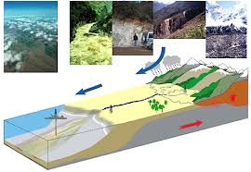

Cartoon showing movement of material from mountain to basin.
http://www.crpg.cnrs-nancy.fr/spip.php?article1436

Specifically, I’m looking at these rocks to understand what are the sources for these rocks. The terrestrial fluvial rocks contain basalt clasts, which we hypothesize, are coming from a rock unit within the southern Patagonian Andes. If these basalt clasts are matched to the rock unit within the mountain range, then that means uplift of the mountain range lead to erosion and subsequent deposition of the terrestrial fluvial rocks.
This is one specific example of looking at sedimentary rocks to figure out what has happened tectonically in the geologic past. Other geologists are looking at sediment origin to understand earthquake recurrence intervals in the Himalayas and still other geologists are using sediment origin to understand what the geography and topography of an area may have looked like in the Book Cliffs of Utah.

