http://blogs.agu.org/landslideblog/2017/01/18/mount-sulzer-avalanches-2/
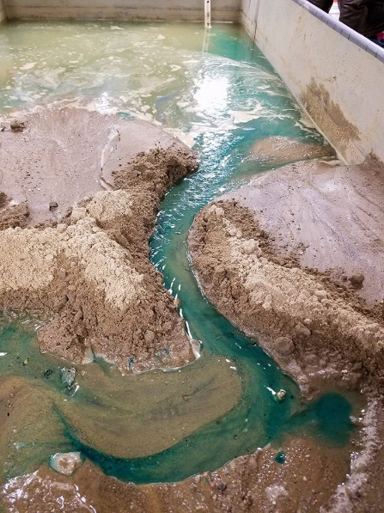
Earlier today I came across a blog post accompanied by an aerial video of the destructive force known as an avalanche. This video, embedded in the blog linked above, is courtesy of Mike Loso and Luke Wassink of the National Park Service, and shows an avalanche occurring at Mount Sulzer. This mountain is in Wrangell-St. Elias National Park in Alaska.
An avalanche can function similarly to what we observed in class recently, as seen in Figure 1, where a stream simulation showed the water moving through a channel carved through the sediment. Similar to this experiment, the video linked above shows the snow, ice, and debris moving through a channel in the side of the mountain. Why would this channel curve however rather than move in a straight line? There are several possible causes for this, and can apply to both liquid water and ice.
Figure 1: Stream Channel Simulation, with blue dye used to show stream direction – picture by Scott Rowan
The first reason is the type of sediment the fluid is traveling through. In the case of the stream simulation, the sediment we used was very soft, allowing for the water to cut out a channel in the sediment. The same process is very plausible for ice to carve out a similar channel in a mountainside. This brings up another question though. Why does the channel meander? This is often because the fluid reaches harder sediments or rocks, which are going to be more difficult to cut through. Taking a path of less resistance, these fluids will travel around the obstacle, if they can’t cut through or erode the obstacle itself. Whether it is a stream eroding the river bank using liquid water or ice carving out a path through rock, carrying debris with it, water, in both its liquid and solid forms, is very powerful.
Clayton Trahan

